User Story for Shopping App

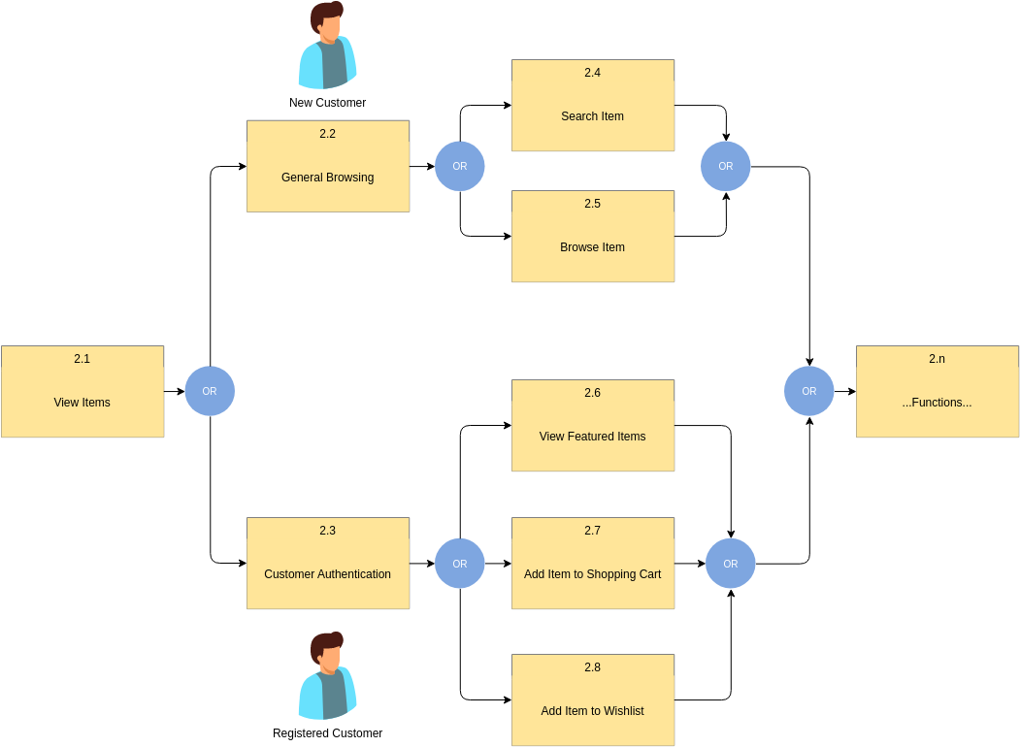

View Items:

* As a shopper, I want to view detailed information about the individual items so that can make informed purchasing decisions.

General Browsing:

* As a user, I want to browse different categories of items to explore available products and discover new ones.

Search Item:

* As a customer, I want to search specific items by entering words so that I can quickly find what I’m looked for.

Browse Item:

* As a user, I want to browse items by category or filters (eg. Price range, brand etc.) to find relevant products.

Customer Authentication:

* As a registered user, I want to securely log in to my account using my username and password so that i can easily access my personalized features and information.

View Featured Items:

* As a shopper, I want to view accurate selection of recommended items on the homepage to discover popular or trending items.

Add Items to Shopping Cart:

* As a customer, I want to add items to my shopping cart from the product detail page so that I can proceed to checkout and purchase them.

Add Items to Wishlist:

* As a customer, I want to add items to my wishlist so that I can save them for future reference or purchases.
* Each of the user story represents a specific functionality or feature from the perspective of the end user.
* They can capture the customer needs, goals, and intentions related to interacting with e-commerce platform, and helping to guide the development process and meets customer expectations.